Test Case: tc001_SPX_Dev5_Crear_Requisicion_Spot_Tipo_Cobro_CC
Step 1 - Enter username and password and click to button Enter : Credentials Entered
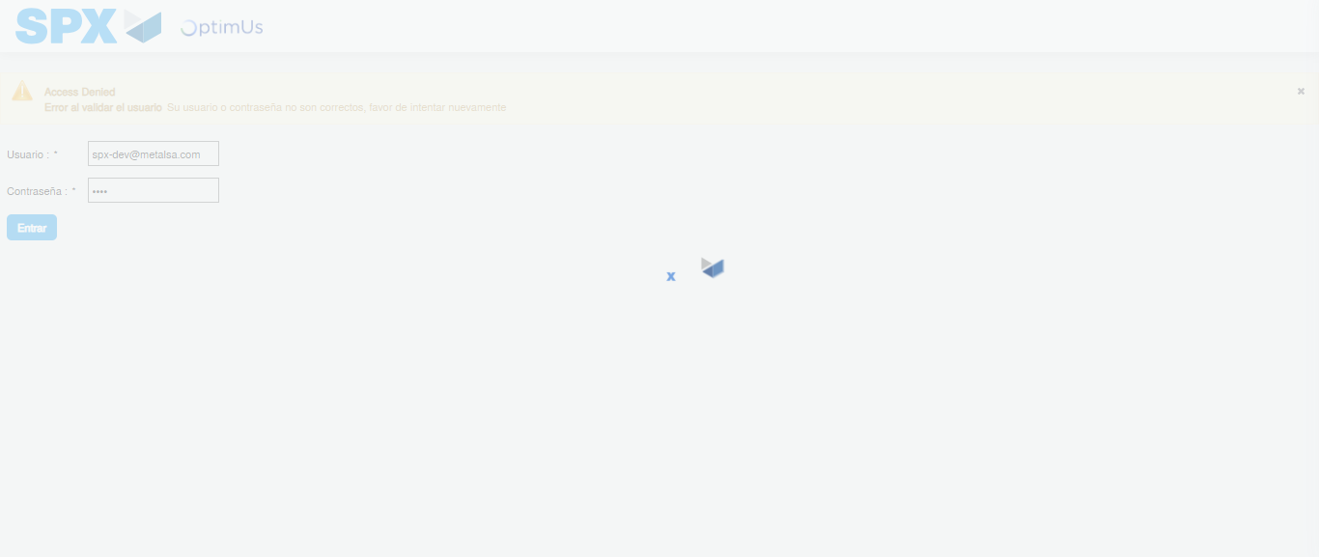Image file-name: QC_Testing-tc001_SPX_Dev5_Crear_Requisicion_Spot_Tipo_Cobro_CC-1783979941517

Step 2 - Select to UEN and Access to Spot Buy Requisitions : UEN Correctly selected and Correct access
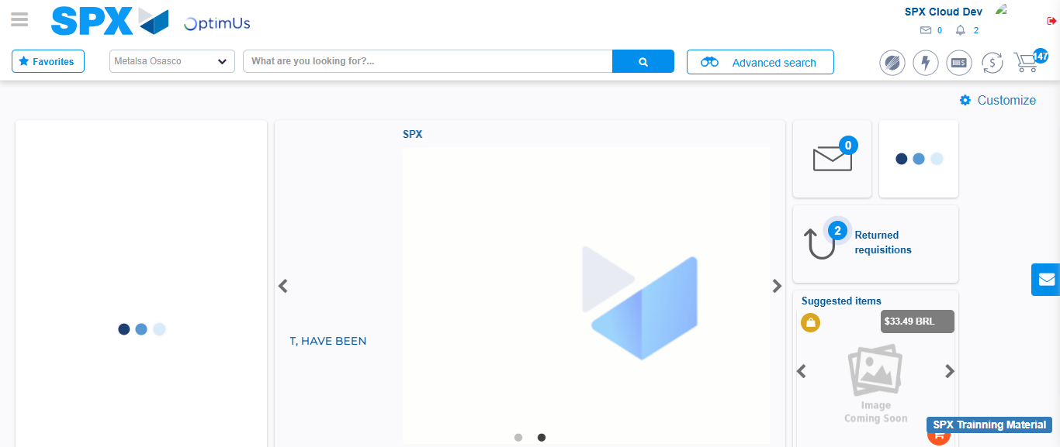Image file-name: QC_Testing-tc001_SPX_Dev5_Crear_Requisicion_Spot_Tipo_Cobro_CC-1783979967580

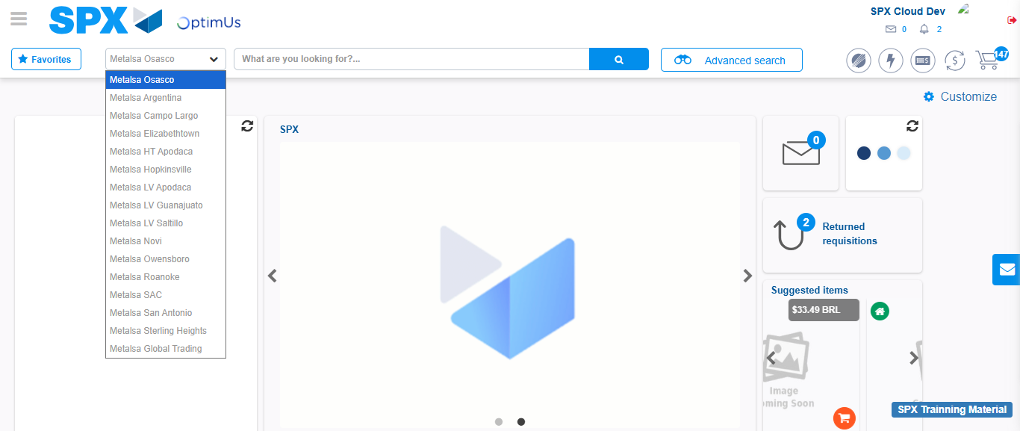Image file-name: QC_Testing-tc001_SPX_Dev5_Crear_Requisicion_Spot_Tipo_Cobro_CC-1783979970172

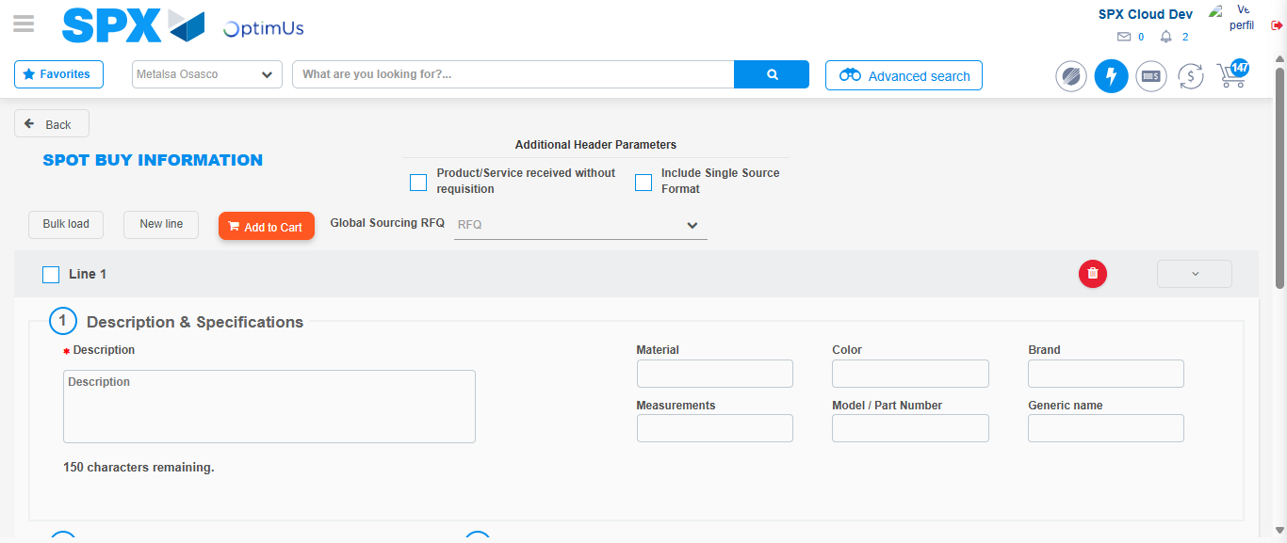Image file-name: QC_Testing-tc001_SPX_Dev5_Crear_Requisicion_Spot_Tipo_Cobro_CC-1783979992896

Step 3 - Data Capture Spot Buy Requisition : Data captured correctly
Image file-name: QC_Testing-tc001_SPX_Dev5_Crear_Requisicion_Spot_Tipo_Cobro_CC-1783979993114

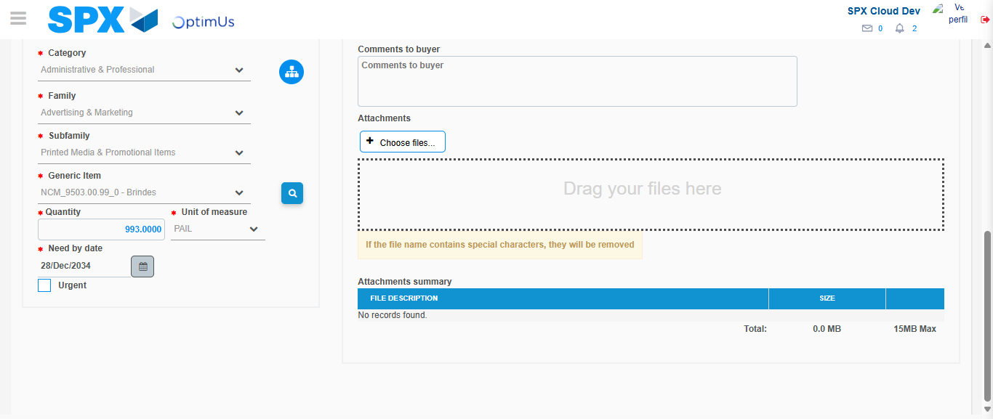Image file-name: QC_Testing-tc001_SPX_Dev5_Crear_Requisicion_Spot_Tipo_Cobro_CC-1783980005337

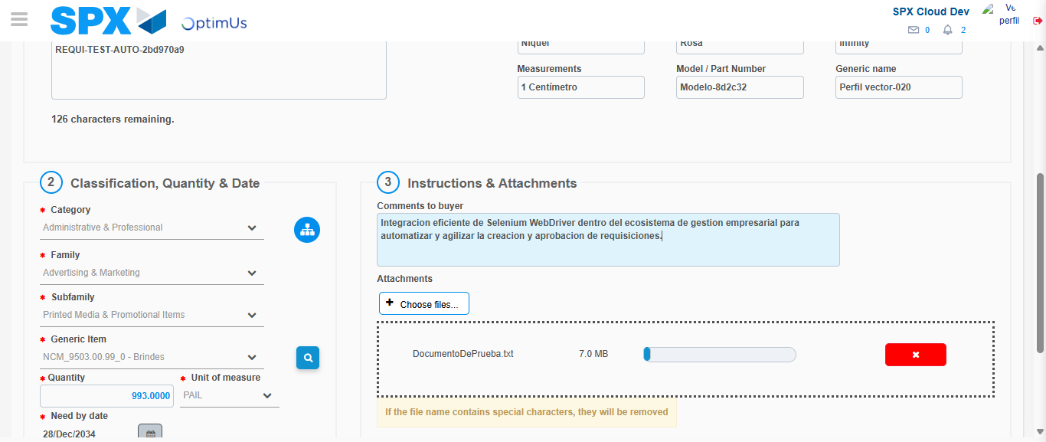Image file-name: QC_Testing-tc001_SPX_Dev5_Crear_Requisicion_Spot_Tipo_Cobro_CC-1783980006101

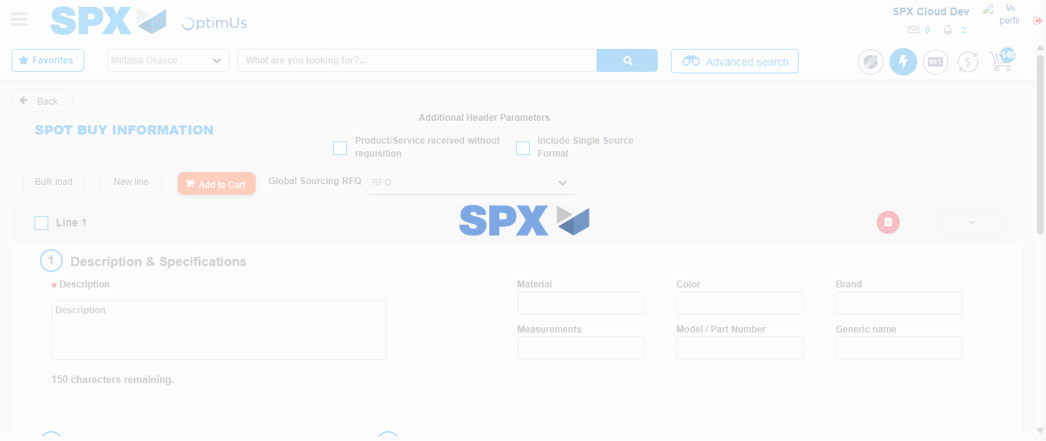Image file-name: QC_Testing-tc001_SPX_Dev5_Crear_Requisicion_Spot_Tipo_Cobro_CC-1783980010086

Step 7 - Return to Main Page SPX : Return to Main Page SPX
Image file-name: QC_Testing-tc001_SPX_Dev5_Crear_Requisicion_Spot_Tipo_Cobro_CC-1783979967580

Image file-name: QC_Testing-tc001_SPX_Dev5_Crear_Requisicion_Spot_Tipo_Cobro_CC-1783979970172

Image file-name: QC_Testing-tc001_SPX_Dev5_Crear_Requisicion_Spot_Tipo_Cobro_CC-1783979992896

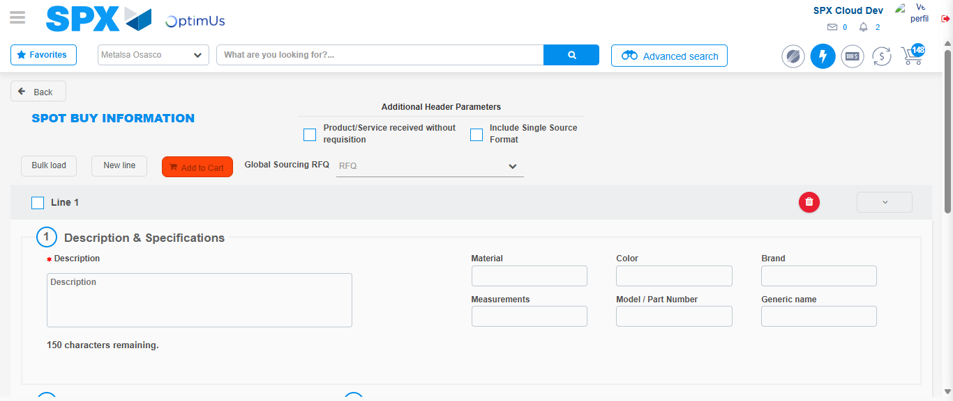Image file-name: QC_Testing-tc001_SPX_Dev5_Crear_Requisicion_Spot_Tipo_Cobro_CC-1783980012352

Image file-name: QC_Testing-tc001_SPX_Dev5_Crear_Requisicion_Spot_Tipo_Cobro_CC-1783980012510

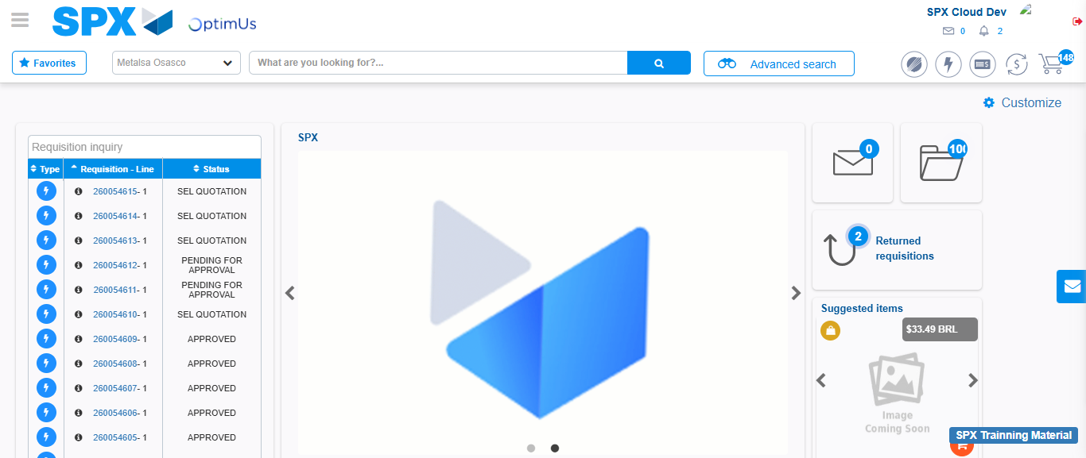Image file-name: QC_Testing-tc001_SPX_Dev5_Crear_Requisicion_Spot_Tipo_Cobro_CC-1783980033553

Step 8 - Log Out : Log Out SPX
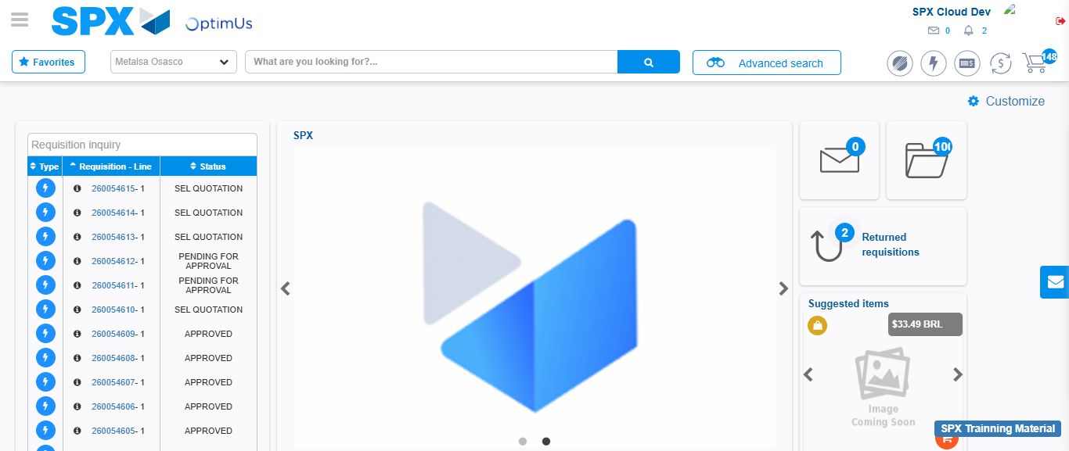Image file-name: QC_Testing-tc001_SPX_Dev5_Crear_Requisicion_Spot_Tipo_Cobro_CC-1783980033842

